Daystar University Career Fair: Focus on Technology

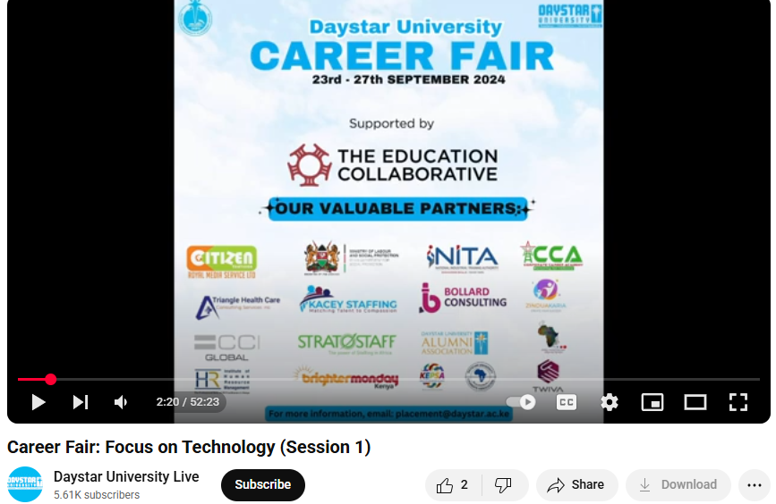
Daystar University Career Fair
Link: https://www.youtube.com/watch?v=cMgki1oe9lE

