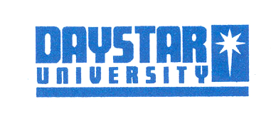
SCHOOL OF COMMUNICATION LANGUAGE AND PERFORMING ARTS

Media and film studies Department

ART IN AFRICA
Art 111A and T

Final Exam

January Semester 2019

Duration 2 hrs

INSTRUCTIONS:

SECTION A
ANSWER QUESTION 1A OR QUESTION 1B.
THEN ANSWER ALL OTHER QUESTIONS IN THIS SECTION

SECTION B
ANSWER ALL QUESTIONS

SECTION A
ANSWER QUESTION 1A OR 1B
1A. Define the following terms:
- Monozylem
- Cire Perdue
- Split complementary
- Stippling (4marks)

1B Define the following terms:
- petroglyphs
- color wheel
- masquerade
- bas relief ( 4 marks)

SECTION B

ANSWER ALL QUESTIONS IN THIS SECTION
- Describe 4 methods of making sculpture. Give an example of each (4 marks)

- Explain three characteristics of African art. (3 marks)

- What are the different classes of rock art in the Sahara region? (4 marks)

- Explain 3 different styles of Western art from which many African artists today have borrowed styles, materials and ideas. (6 marks)

SECTION B
ANSWER ALL QUESTIONS

- Describe the steps involved in art criticism. (4 marks )

- Use the steps in question 6 to critique visual below (8 marks)

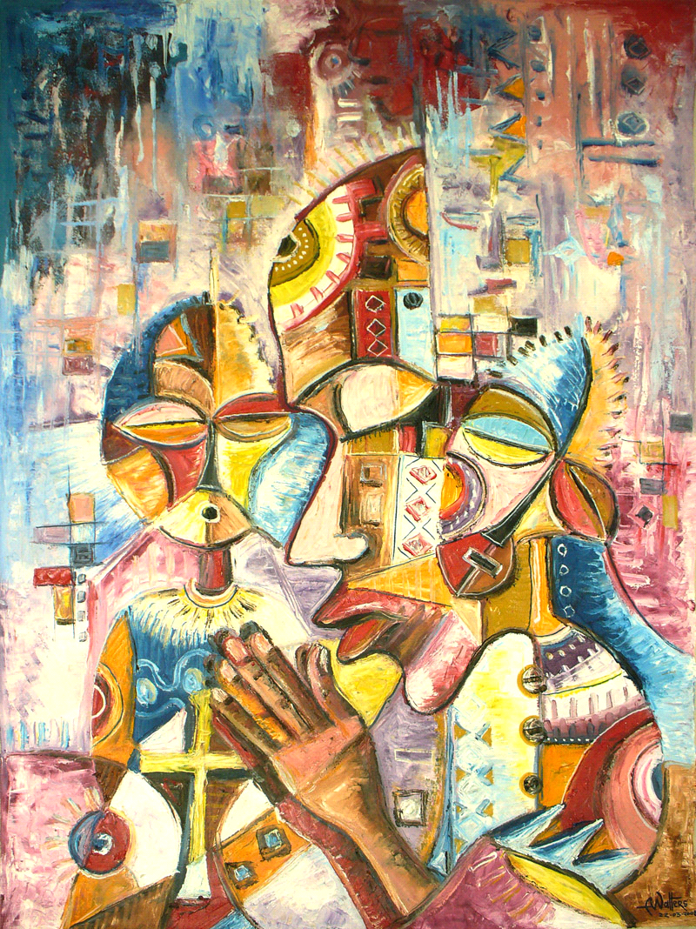
Artist unknown. Oil on canvas.

