SCHOOL OF SCIENCE, ENGINEERING AND HEALTH

DEPARTMENT OF COMPUTER SCIENCE

FINAL EXAMINATION JUNE 2018 SEMESTER

BMS 409: BIOMETRICS.

DATE: JULY 2018 TIME: 2 HOURS
INSTRUCTIONS: Answer all questions

SECTION 1 [30Marks]
- Define the following terms as used in Biometrics [4Marks]
  - False Rejection Rate
likelihood that the biometric security system will incorrectly reject an access attempt by an authorized user.
  - Cancellable biometrics
refers to the intentional and systematically repeatable distortion of biometric features in order to protect sensitive user-specific data.
- The last few years we have seen a shift from token based and knowledge-based authentications modes to biometrics. Mention THREE shortcomings of the previous modes of identification that have led to the growth of biometrics [3Marks]
  - Card may be lost, stolen or forgotten
  - Password or PIN may be forgotten or guessed by the imposters
  - 25% of people seem to write their PIN on their ATM card
  - Identity theft
  - The traditional approaches are unable to differentiate between an authorized person and an impostor

- With the help of a diagram, describe the enrollment process of a biometric system
[4Marks]
2mkars for diagram 2marks for explanation
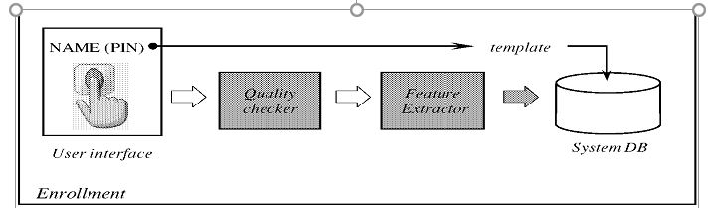
- Uniqueness and permanence and fundamental attributes of any biometric identifier. Mention any THREE characteristics of the iris that guarantee the two attributes[3Marks]
  - Highly protected, internal organ of the eye
  - Externally visible; patterns imaged from a distance
  - Uniqueness: set by combinatorial complexity
  - Changing pupil size confirms natural physiology
  - Limited genetic penetrance of iris patterns
  - Patterns apparently stable throughout life.
  - A key advantage of iris recognition is its stability, or template longevity- a single enrollment can last a lifetime.

- State any THREE unique traits that a dynamic signature verification system should analyzing in validation of identity [3Marks]
- speed,
- acceleration,
- pressure
- completed signature’s static shape.
- Describe feature level fusion [4Marks]
(any of the three, description 2marks, diagram 2marks)
  - Feature Level Fusion
Combining feature vectors Fusion at feature level is expected to provide better recognition results but it has also observed that when features of different modalities are compatible with each other then fusion at feature level achieves more accuracy
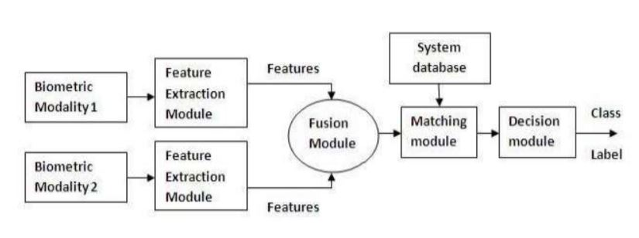
- Compare face recognition to fingerprint recognition [4Marks]
Face-recognition | Fingerprint
Non intrusive | intrusive
Can be passive | Not passive
Existing cameras can be used hence chapear | Extra hardware is needed
May not work for identical twins | Very distinct even for identical twins
- Differentiate dwell time from flight time as used in keystroke biometric [2Marks]
Dwell time is the time duration that a key is pressed
Flight time is the time duration in between releasing a key and pressing the next key

- Provide with handprints, explain specific characteristic you would look at in performing hand geometry to verify a claimed identity [3Marks]
- length of the hand
- width of the hand
- length of the fingers
- width of the fingers
SECTION II: APPLICATION (ANSWER ALL QUESTIONS) [30 MARKS]
In 2014, Daystar University collected students’ biometric data namely fingerprints. This exercise involved the use of a unimodal biometric system. In 2017 the unimodal system was changed to a multimodal system.
- With the help of a well labelled diagram highlight the function of the different parts(components) of a fingerprint biometric system [8marks]
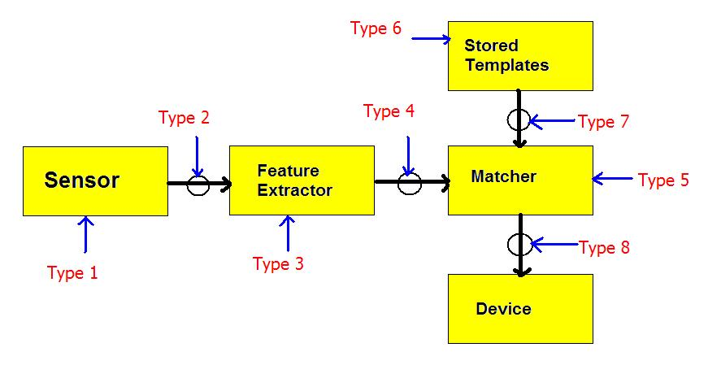
  - Sensor Module- It captures the Biometric data of an Individual. An example can be a Fingerprint Sensor.
  - Feature Extraction Module- Here the obtained biometric data of an Individual is processed to extract features. Example can be the Local ridge feature extraction from a Fingerprint.
  - Matcher Module- Here the features extracted during the above phase are matched against the templates stored in the database.
  - System Database Module- Used to Store Biometric templates of the users enrolled. The enrollment module is responsible for Enrolling Individuals to the database.

- Highlight THREE benefits of using fingerprints as the biometrics modality of choice
[3marks]
- Very high accuracy.
- Is the most economical biometric PC user authentication technique.
- Easy to use.
- Small storage space required for the biometric template, reducing the size of the database memory required
- It is standardized.
- Mention TWO application areas where the university can use the biometric data [2marks]
  - Attendance
  - Entry to authorize areas
  - Victim identification in case of accidents
- Differentiate a unimodal from multimodal biometric system [4Marks]
Unimodal biometric system are the biometric identifiers that only use one modality eg fingerprint
Multimodal biometric systems use more than once modality and fuse the results for a higher rate of recognition eg using fingerprint and face recognition
- Given that 4500 fingerprints were collected how many are likely to have the arc pattern
[2marks]
(5/100)*4500=225
- Describe any THREE possible attacks of a biometric system that the university should be aware of
anythree [3marks]
- Replay attack
- Electronic Impersonation
- Trojan Horse
- Denial
- Communication
- Mention THREE challenges of a unimodal system that may have prompted Daystar University to adopt the use of a multimodal system [3marks]
Any three
  - Noisy data : Susceptibility of biometric sensors to noise leads to inaccurate matching, as noisy data may lead to false rejection.
  - Intra class variation : The biometric data acquired during verification will not be identical to the data used for generating template during enrollment for an individual. This is known as intra-class variation. Large intra-class variations increase the False Rejection Rate (FRR) of a biometric system.
  - Interclass similarities : Inter-class similarity refers to the overlap of feature spaces corresponding to multiple individuals. Large Inter-class similarities increase the False Acceptance Rate (FAR) of a biometric system.
  - Non universality “ Failure to enroll(FTE) ”: Some persons cannot provide the required standalone biometric, owing to illness or disabilities.
  - Spoofing : Unimodal biometrics is vulnerable to spoofing where the data can be imitated or forged.

- Describe any mode of operation the university can use in its multimodal system [3marks]
Any of the three
Serial ,Parallel and Hierarchical description(1.5) diagram(1.5)
Parallel
- Information from multiple traits is used simultaneously to perform recognition.
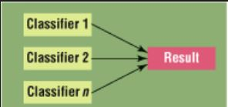
- Recommend any scenario of multimodal biometric system to the university [2marks]
Multiple sensors : multiple sensors are used to sense the same biometric identifier.
Multiple Biometrics : sense different biometric identifiers.
Multiple Units : fingerprints from two or more fingers.
Multiple Snapshots : more than one instance of the same biometric.
Multiple Matching algorithm : combines different representation and matching algorithms.

