ARTS AND HUMANITIES
EDUCATION DEPARTMENT
EDU 365T: CHRISTIAN RELIGIOUS EDUCATION TEACHING METHODS
END OF JANUARY 2018 SEMESTER EXAMINATION

Instructions:
Answer Questions One and any other TWO questions from the choices provided.
Time: 2 hours

1a. Give 3 rationales for preparing scheme of work of CRE (6 Marks).
b. Identify 5 key components of a Daystar University lesson Plan that are important in a CRE Lesson (5 Marks).
c. Discuss three types of questions that are particularly important in a CRE lesson (9 Marks)
2. Study the Dale Cone of Experience presented below
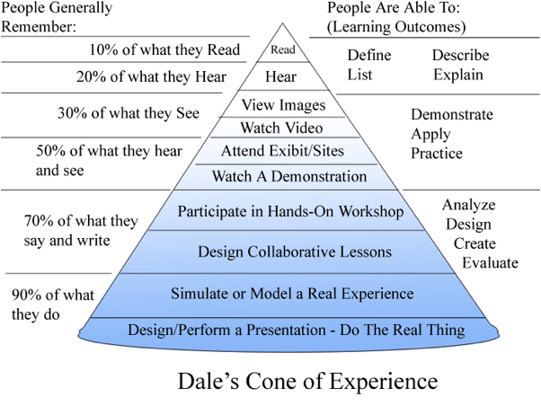

Discuss 10 key lessons you deduce from the cone of experience (20 Marks).

3a Identify 6 levels of learning according to revised Blooms Taxonomy actions Verbs (6 Marks).

b. Give the meaning of the term “student engagement” (4 Marks)

c. Supposing you are to teach a lesson on Faith and Obedience based on Abraham story of faith. Describe 5 methods that would increase student engagement in your lesson (10 Marks).
4. Provide 10 justifications for constructivism as a 21st century method of teaching Christian Religious Education. (20 Marks).
5. You have planned to teach the topic on King David in a Form One class using class discussion method. Discuss what will happen in your CRE lesson prior to lesson and during class. (20 Marks).

