ART 111 A & T

SCHOOL OF COMMUNICATION, LANGUAGES & PERFORMING ARTS

DEPARTMENT OF COMMUNICATION

ART 111: ART IN AFRICA A & T

FINAL EXAM

JUNE SEMESTER 2017

INSTRUCTIONS

Answer question 1(Compulsory) and choose any other two.
This paper carries a total of 40 marks.
This paper is two hours long.
Write legibly.
Cheating is prohibited.

QUESTIONS

Section One: Compulsory

- i) Explain the authenticity of African art. (3mks)
ii) Discuss three ways in which European art influenced African art. (3mks)
iii) Discuss any four elements of art most often used by artists. (4mks)
2. Critically examine the following image and comment on the following:
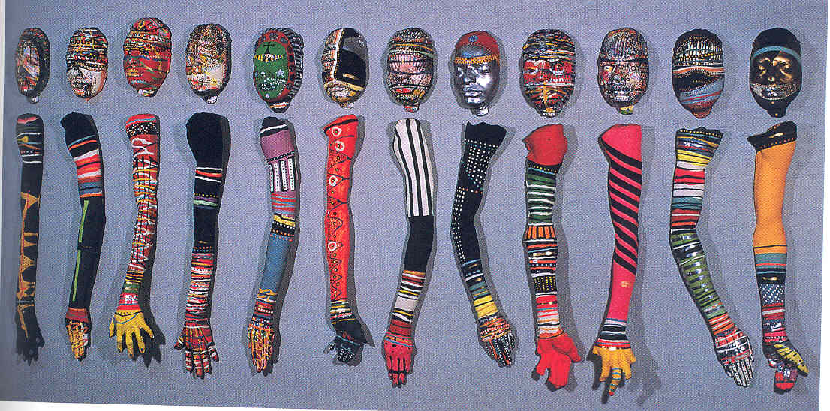
i) Unity and variety (4mks)
ii) Balance (2mks)
iii) Emphasis and focal point (1mk)
iv) The communication behind the image (2mks)
v) Classify the image (1mk)

3. Either imagine drawing/painting an object or objects, or actually draw an image/object(s) of your choice and do the following:
i) Explain the function of your image (2mks)
ii) Explain the communication behind your image (2mks)
iii) Classify the image (2mks)
iv) Explain the form of your artwork (2mks)

Section Two: Choose one question

4.
a) In your opinion, is African art formalist, representational or instrumentalist? Justify your answer. (2mks)
b) Explain two types of rock art in Africa. (6mks)
c) Describe any two techniques involved in making African sculpture. (4mks)
5.
a) “Every piece of artwork is a communication.” Examine any two themes of art in general. (6mks)
b) Explain three functions of African art. (6mks)

